DAT 515 uCertify Lab Activity Worksheet

Overview
This course uses uCertify virtual labs to practice working with the techniques and tools covered in the module learning. This lab activity worksheet will assist you in organizing your work and submitting the assigned labs throughout the term. Please note that the number of labs assigned in each module may vary, so adjust your uCertify Lab Activity Worksheet accordingly. Replace all bracketed text in this worksheet with the appropriate responses.

Instructions
For each lab assigned in the module, you must:

- Save a copy of the uCertify Lab Activity Worksheet using the following naming convention, replacing the bracketed text: DAT_515_Module_[Number]_uCertifyLabActivity_[First Initial, Last Name].docx
- Follow the instructions in uCertify to complete all aspects of each lab. Be sure to follow each step carefully and thoroughly test your work.
- Take screenshots of the completed labs using the uCertify snipping tool. Ensure your name and the lab number are visible. Add the screenshots to the Lab Screenshots section below.
- Answer the lab reflection prompts provided below.
- Save and submit your completed worksheet in Brightspace to be graded by your instructor.

Module Labs
Module 3
2.2.1
2.4.1
2.5.1
2.6.1
2.6.2
2.7.1
3.10.1
3.11.1
3.12.1
3.13.1

Lab Screenshots
2.2.1
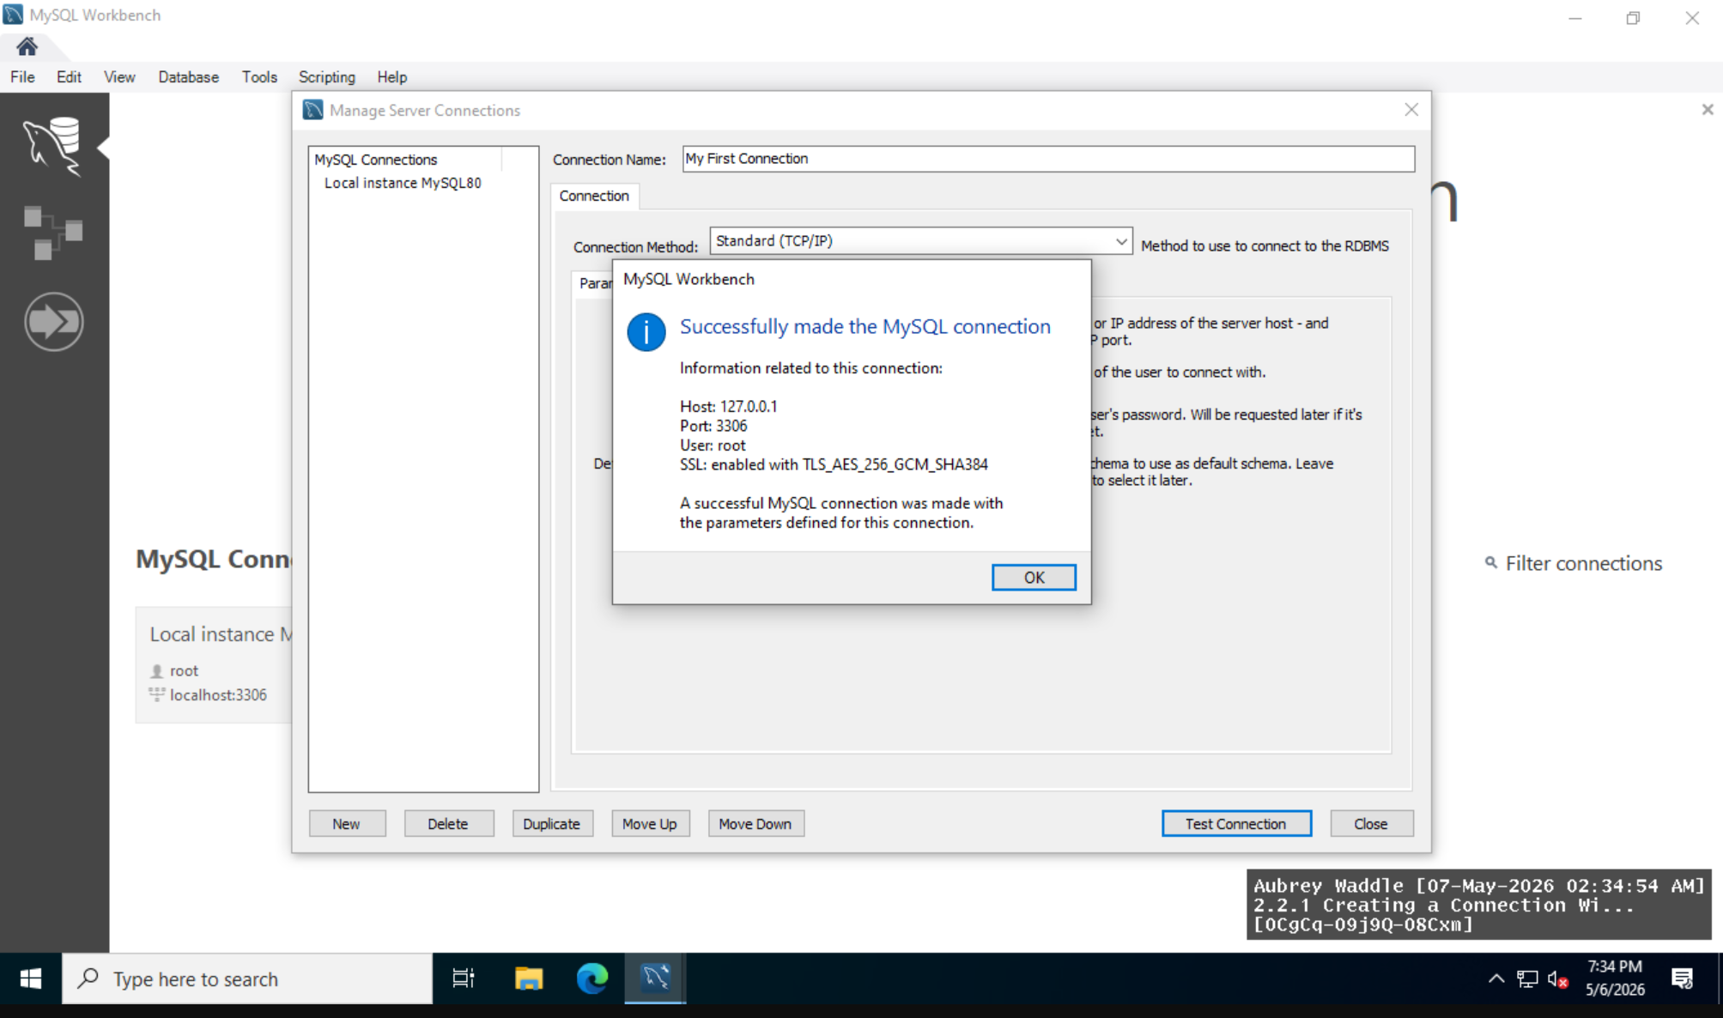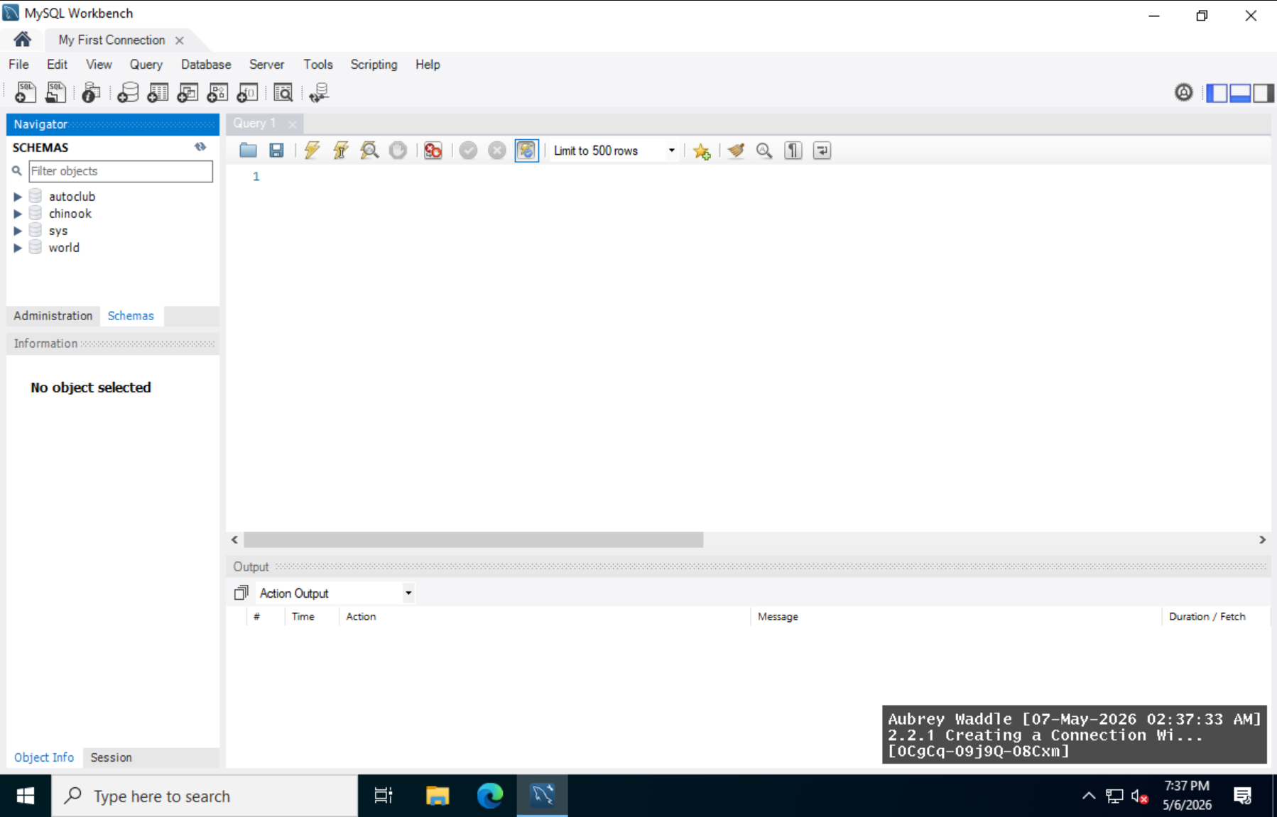
2.4.1
2.5.1
2.6.1
2.6.2
2.7.1
3.10.1
3.11.1
3.12.1
3.13.1

Lab Reflection
2.2.1
2.4.1
2.5.1
2.6.1
2.6.2
2.7.1
3.10.1
3.11.1
3.12.1
3.13.1

